|  |  |
| --- | --- |
| Canon EOS-1D X Mark III camera  Máy ảnh Canon EOS-1D X Mark III  Canon EOS 1DX III 1 Canon EOS 1DX III 9 Canon EOS 1DX III 8 Canon EOS 1DX III 2 | **Featured information:**  191 focus points through viewfinder  20.1MP Full-Frame CMOS sensor  Canon Dual Pixel CMOS AF 525 optional zones  Record 4K 60fps video  Price : $ 52000  **Specifications:**  Sensor Type  CMOS  Image Format  JPEG, Raw, HEIF  Anti-Vibration  In-body 5-axis electronic image stabilization  Lens Mount  Canon EF  Sensor Format  Full-Frame (1x Crop Factor)  Resolution  20.1 Megapixels  Size photo  5472 x 3648  Image Proportions  3:2 |

**Overview:**

The Canon EOS 1D X Mark III uses a completely new 20.1MP sensor combined with the DIGIC moire application.

This combination also allows the Canon EOS 1D X Mark III to shoot continuously at 20 frames per second in Live View mode or 16 frames per second with the viewfinder. In particular, the buffer memory allows the device to store up to 1,000 photos when using two CFexpress memory cards.

The ISO range is also expanded, in normal mode the 1DX Mark III provides ISO 100 - 102,400, and is expandable from 50 - 819,200. The resulting images are of better quality than previous models despite shooting at high ISO, meeting the needs of working in different lighting conditions.

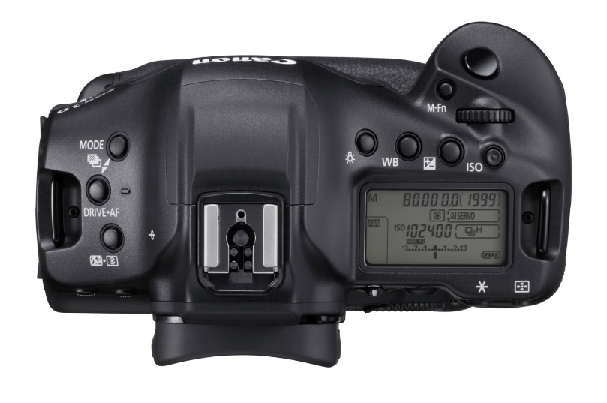

The Canon EOS 1D X Mark III features a wide color space with HDR HEIF imaging options, providing greater highlight detail when displayed on compatible monitors and printers. In addition, clarity-in-camera control is also new that allows adjustment of contrast and midtone.

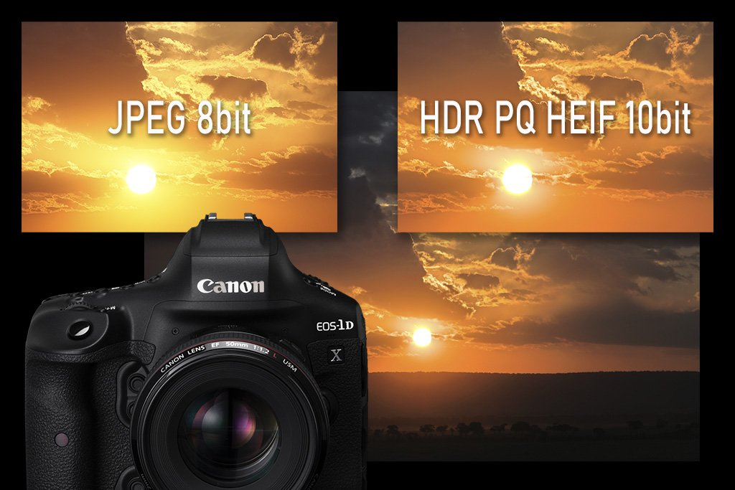

Equipped with a new AF system, the EOS 1D X Mark III is a Canon camera with powerful, accurate autofocus capabilities. With 191 focus points through the viewfinder and new AF tracking capabilities, it delivers fast, absolutely accurate results. In addition, Head Detection technology combined with Deep Learning algorithms helps recognize faces easily through the ability to read and analyze subjects thanks to shape and color.

